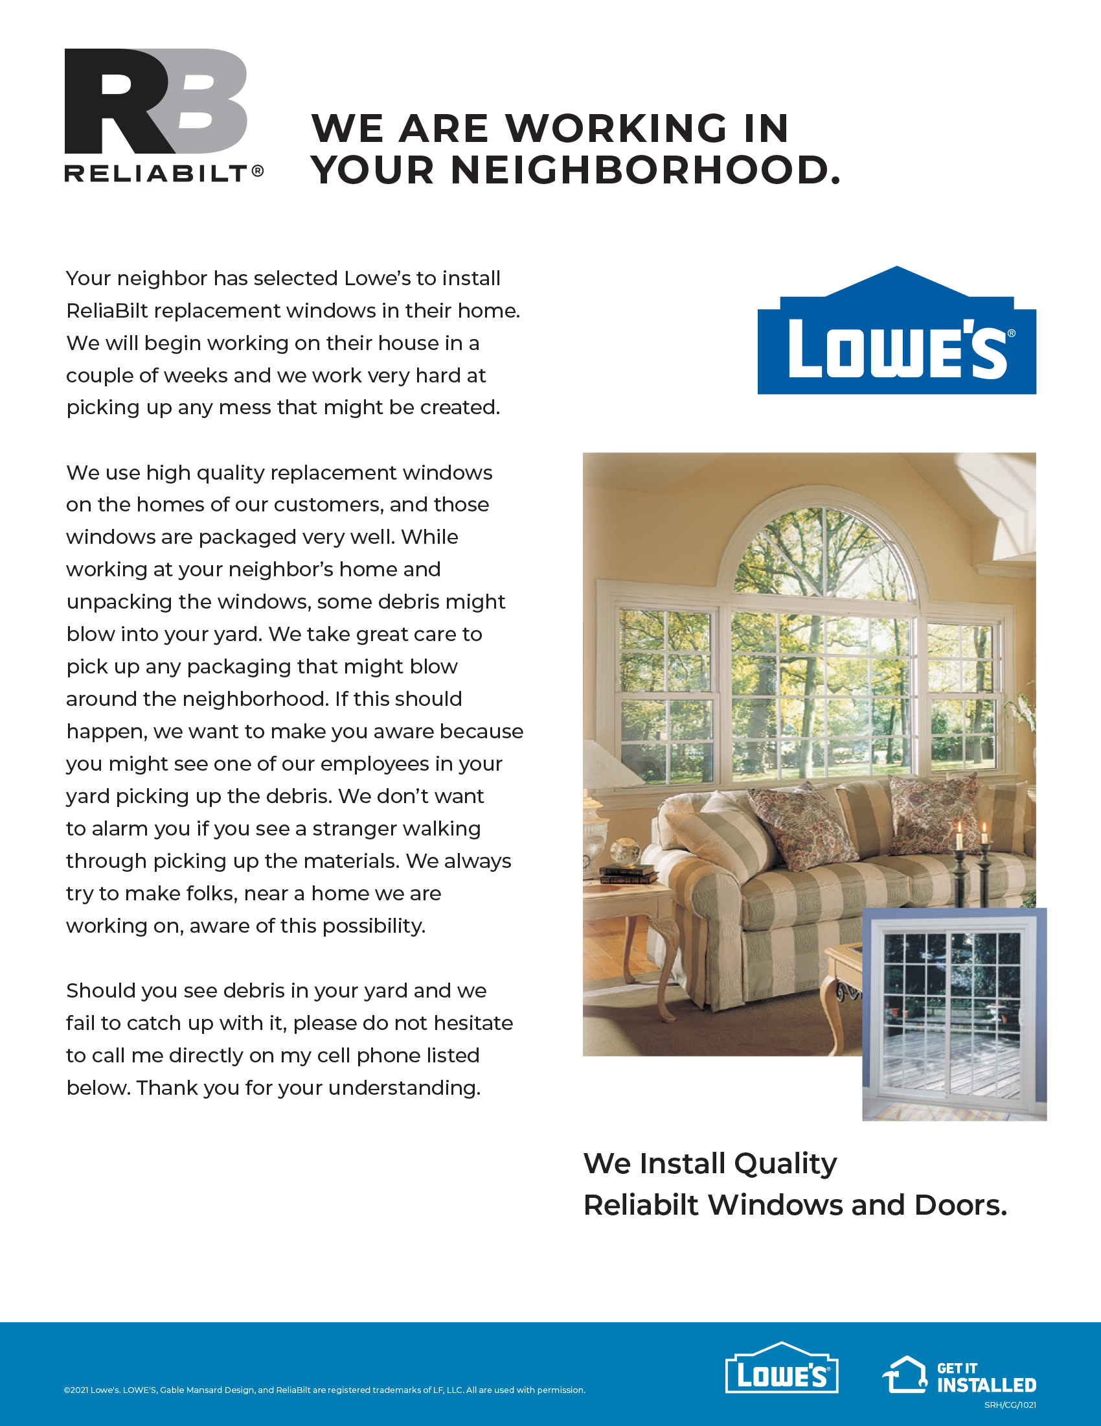
CALL 800-999-9999 FOR DETAILS.
Sincerely,

Representative Name
PSE – Store #XXXX
999-999-9999

