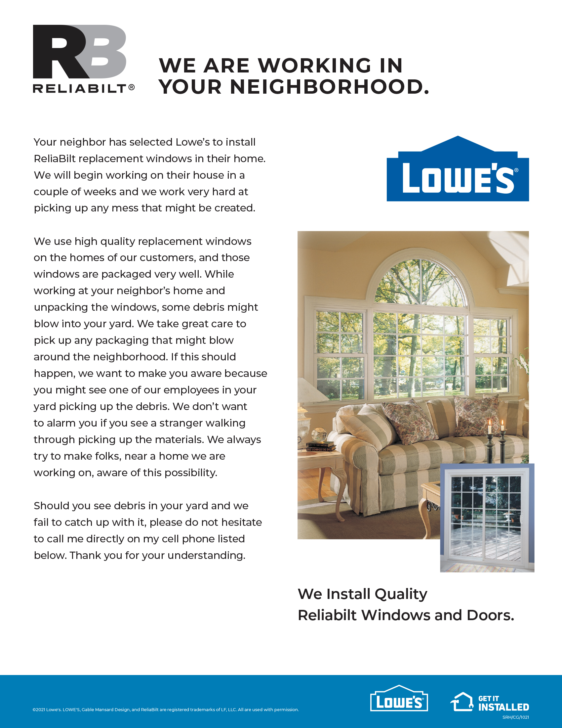

**CALL 800-999-9999 FOR DETAILS.**

Sincerely,

Representative Name

PSE – Store #XXXX

999-999-9999